https://www.simplilearn.com/top-sql-interview-questions-and-answers-article#GoTop

SQL is a Structured query language used to access and manipulate data in databases.
SQL is a programming language used to interact with relational databases. Structured Query Language
It is used to perform CRUD operations :
Create
Read
Update
Delete
Whether we’re handling a small user database or analyzing terabytes of sales records, SQL allows efficient querying, updating, and management of relational databases.
When data needs to be retrieved from a database, SQL is used to construct and send the request. The Database Management System (DBMS) processes the SQL query, retrieves the requested data, and returns it to the user or application.

Databases: Databases are structured collections of data organized into tables, rows, and columns.
- A software application used to manage our DB is called DBMS (Database Management System)
- Types of Databases
- Relational ; Data stored in tables
- Non-relational (NoSQL) ;data not stored in tables
- Constraints: Constraints are rules applied to tables to maintain data integrity. Constraints define conditions that data must meet to be stored in the database, ensuring accuracy and consistency.

Types of SQL Commands
There are four types of SQL commands: DDL, DML, DCL, TCL.

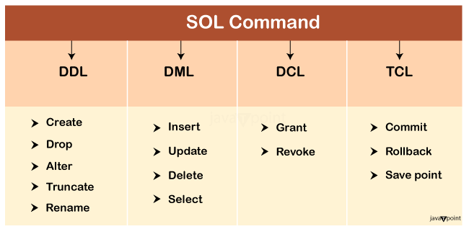

1. Data Definition Language (DDL)
- DDL changes the structure of the table like creating a table, deleting a table, altering a table, etc.
- All the command of DDL are auto-committed that means it permanently save all the changes in the database.
c. ALTER: It is used to alter the structure of the database. This change could be either to modify the characteristics of an existing attribute or probably to add a new attribute.
Following are the list of modifications that can be done using ALTER command.
- With the use of ALTER commands we can add or drop one or more columns form existing tables.
- Increase or decrease the existing column width by changing the data type
- Make an existing mandatory column to optional.
- Enable or disable the integrity constraints in a table. We can also add, modify or delete the integrity constraints from a table.
- We can also specify a default value for existing column in a table.

2. Data Manipulation Language
- DML commands are used to modify the database. It is responsible for all form of changes in the database.
- The command of DML is not auto-committed that means it can't permanently save all the changes in the database. They can be rollback.

SQL CREATE DATABASE

Syntax
The syntax to use the CREATE DATABASE command in SQL is:
CREATE DATABASE database_name;

Database related Queries
CREATE DATABASE db_name;
DROP DATABASE db_name;
SHOW DATABASES; (It will return a list of databases that exist in our system.)
SHOW TABLES; (it will return a list of databases that exist in our system.)
CREATE DATABASE IF NOT EXISTS db_name; (If we give IF NOT EXIST , then it’ll created databases if only it is not present from before)

- If you try to create a table/database that already exists, MySQL will throw an error. To avoid this, you can use the CREATE TABLE IF NOT EXISTS syntax.

DROP DATABASE IF EXISTS db_name; (If we give IF EXIST ,then it’ll drop databases if only it is present from before )

USE Database in SQL
To use a specific database in SQL, we use the USE Statement.
The syntax to use a database in SQL is:
USE database_name;

SQL CREATE TABLE
This statement also allows to create table with constraints,that define the rules for the table. Users can create tables in SQL and insert data at the time of table creation.
Constraints are the rules that we can apply on the type of data in a table. That is, we can specify the limit on the type of data that can be stored in a particular column in a table using constraints.
- NOT NULL: This constraint tells that we cannot store a null value in a column. That is, if a column is specified as NOT NULL then we will not be able to store null in this particular column any more.
- UNIQUE: This constraint when specified with a column, tells that all the values in the column must be unique. That is, the values in any row of a column must not be repeated it can contain null value.
- PRIMARY KEY: A primary key is a field which can uniquely identify each row in a table. And this constraint is used to specify a field in a table as primary key.
- FOREIGN KEY: A Foreign key is a field which can uniquely identify each row in another table. And this constraint is used to specify a field as foreign key.
- CHECK: This constraint helps to validate the values of a column to meet a particular condition. That is, it helps to ensure that the value stored in a column meets a specific condition.
- DEFAULT: This constraint specifies a default value for the column when no value is specified by the user.

CREATE TABLE sample_table
(
column1 data_type(size) constraint_name,
column2 data_type(size) constraint_name,
column3 data_type(size) constraint_name,
);

sample_table: Name of the table to be created.
data_type: Type of data that can be stored in the field.
constraint_name: Name of the constraint. for example- NOT NULL, UNIQUE, PRIMARY KEY etc.

CREATE TABLE Student
(
ID int(6) NOT NULL,
NAME varchar(10) NOT NULL,
ADDRESS varchar(20)
);
UNIQUE –
This constraint helps to uniquely identify each row in the table. i.e. for a particular column, all the rows should have unique values. We can have more than one UNIQUE columns in a table.
CREATE TABLE Student
(
ID int(6) NOT NULL UNIQUE,
NAME varchar(10),
ADDRESS varchar(20)
);
PRIMARY KEY –
Primary Key is a field which uniquely identifies each row in the table. If a field in a table as primary key, then the field will not be able to contain NULL values as well as all the rows should have unique values for this field. So, in other words we can say that this is combination of NOT NULL and UNIQUE constraints.
A table can have only one field as primary key. Below query will create a table named Student and specifies the field ID as primary key.
CREATE TABLE Student
(
ID int(6) NOT NULL UNIQUE,
NAME varchar(10),
ADDRESS varchar(20),
PRIMARY KEY(ID)
);
FOREIGN KEY –
Foreign Key is a field in a table which uniquely identifies each row of a another table. That is, this field points to primary key of another table. This usually creates a kind of link between the tables.
Consider the two tables as shown below:
Orders

O_ID | ORDER_NO | C_ID
1 | 2253 | 3
2 | 3325 | 3
3 | 4521 | 2
4 | 8532 | 1
Customers

C_ID | NAME | ADDRESS
1 | RAMESH | DELHI
2 | SURESH | NOIDA
3 | DHARMESH | GURGAON
As we can see clearly that the field C_ID in Orders table is the primary key in Customers table, i.e. it uniquely identifies each row in the Customers table. Therefore, it is a Foreign Key in Orders table.
Syntax:
CREATE TABLE Orders
(
O_ID int NOT NULL,
ORDER_NO int NOT NULL,
C_ID int,
PRIMARY KEY (O_ID),
FOREIGN KEY (C_ID) REFERENCES Customers(C_ID)
)
CHECK –
Using the CHECK constraint we can specify a condition for a field, which should be satisfied at the time of entering values for this field.
For example, the below query creates a table Student and specifies the condition for the field AGE as (AGE >= 18 ). That is, the user will not be allowed to enter any record in the table with AGE < 18. Check constraint in detail

CREATE TABLE Student
(
ID int(6) NOT NULL,
NAME varchar(10) NOT NULL,
AGE int NOT NULL CHECK (AGE >= 18)
);
DEFAULT –
This constraint is used to provide a default value for the fields. That is, if at the time of entering new records in the table if the user does not specify any value for these fields then the default value will be assigned to them.
For example, the below query will create a table named Student and specify the default value for the field AGE as 18.
CREATE TABLE Student
(
ID int(6) NOT NULL,
NAME varchar(10) NOT NULL,
AGE int DEFAULT 18
);

CREATE TABLE EMPLOYEE Example
In this example, we will create table in SQL with primary key, named “EMPLOYEE”.
CREATE TABLE Employee (
EmployeeID INT PRIMARY KEY,
FirstName VARCHAR(50),
LastName VARCHAR(50),
Department VARCHAR(50),
Salary DECIMAL(10, 2)
);

CREATE TABLE Customer(
CustomerID INT PRIMARY KEY,
CustomerName VARCHAR(50),
LastName VARCHAR(50),
Country VARCHAR(50),
Age INT CHECK (Age >= 0 AND Age <= 99),
Phone int(10)
);

SQL INSERT INTO Statement

Syntax
There are two primary syntaxes of INSERT INTO statements depending on the requirements. The two syntaxes are:

The first method is to specify only the value of data to be inserted without the column names.
INSERT INTO table_name
VALUES (value1, value2, value);
Parameters:
- table_name: name of the table.
- value1, value2: value of first column, second column,… for the new record

2. Column Names And Values Both
In the second method we will specify both the columns which we want to fill and their corresponding values as shown below:
INSERT INTO table_name (column1, column2, column3)
VALUES ( value1, value2, value);

CREATE DATABASE StudentDB;
USE StudentDB;

CREATE TABLE Student (
ROLL_NO INT PRIMARY KEY,
NAME VARCHAR(50),
ADDRESS VARCHAR(100),
PHONE VARCHAR(15),
AGE INT
);

INSERT INTO Student (ROLL_NO, NAME, ADDRESS, PHONE, AGE) VALUES
(1, 'Ram', 'Delhi', 'XXXXXXXXXX', 18),
(2, 'Ramesh', 'Gurgaon', 'XXXXXXXXXX', 18),
(3, 'Sujit', 'Rohtak', 'XXXXXXXXXX', 20),
(4, 'Suresh', 'Rohtak', 'XXXXXXXXXX', 18);

SELECT * FROM Student;

INSERT INTO Student (ROLL_NO, NAME, Age)
VALUES ('5','PRATIK','19');

ROLL_NO | NAME | ADDRESS | PHONE | Age
1 | Ram | Delhi | XXXXXXXXXX | 18
2 | RAMESH | GURGAON | XXXXXXXXXX | 18
2 | RAMESH | GURGAON | XXXXXXXXXX | 18
5 | PRATIK | Null | null | 19
Columns not included in the INSERT statement are filled with default values (typically NULL).

Example of Insert Multiple Rows in a table using Single SQL Statement
The following SQL statement inserts multiple rows in Student Table.
Query:
INSERT INTO Student (ROLL_NO, NAME, AGE, ADDRESS, PHONE)
VALUES
(6, 'Amit Kumar', 15, 'Delhi', 'XXXXXXXXXX'),
(7, 'Gauri Rao', 18, 'Bangalore', 'XXXXXXXXXX'),
(8, 'Manav Bhatt', 17, 'New Delhi', 'XXXXXXXXXX'),
(9, 'Riya Kapoor', 10, 'Udaipur', 'XXXXXXXXXX');

Retrieve Data using SELECT Query
In this example, we will fetch CustomerName, LastName from the table Customer:
Query:
SELECT CustomerName, LastName FROM Customer;

Fetch All Table using SELECT Statement
SELECT * FROM Customer;

SELECT Statement with WHERE Clause
SELECT CustomerName FROM Customer where Age = '21';

List of Operators that Can be Used with WHERE Clause
Operator | Description
>= | Greater than or Equal to
<= | Less than or Equal to
= | Equal to
<> | Not Equal to
BETWEEN | In an inclusive Range
LIKE | Search for a pattern
IN | To specify multiple possible values for a column

CREATE TABLE Emp1(
EmpID INT PRIMARY KEY,
Name VARCHAR(50),
Country VARCHAR(50),
Age int(2),
mob int(10)
);

Where Clause with BETWEEN Operator

To fetch records of Employees where Age is between 22 and 24 (inclusive).
Query:
SELECT * FROM Emp1 WHERE Age BETWEEN 22 AND 24;

Where Clause with LIKE Operator
It is used to fetch filtered data by searching for a particular pattern in the where clause.
To fetch records of Employees where Name starts with the letter S.
Query:
SELECT * FROM Emp1 WHERE Name LIKE 'S%';
The ‘%'(wildcard) signifies the later characters here which can be of any length and value.

To fetch records of Employees where Name contains the pattern ‘M’.
Query:
SELECT * FROM Emp1 WHERE Name LIKE '%M%';

Where Clause with IN Operator
SELECT column1, column2 FROM table_name WHERE column_name IN (value1,value2,..);

SELECT Name FROM Emp1 WHERE Age IN (21,23);

AGGREGATE FUNCTION IN SQL
SQL Aggregate Functions are used to perform calculations on a set of rows and return a single value. They are often used with the GROUP BY clause in SQL to summarize data for each group. Commonly used aggregate functions include COUNT(), SUM(), AVG(), MIN(), and MAX().
--Count the number of employees
SELECT COUNT(*) AS TotalEmployees FROM Employee;

-- Calculate the total salary
SELECT SUM(Salary) AS TotalSalary FROM Employee;

-- Find the average salary
SELECT AVG(Salary) AS AverageSalary FROM Employee;

-- Get the highest salary
SELECT MAX(Salary) AS HighestSalary FROM Employee;

-- Determine the lowest salary
SELECT MIN(Salary) AS LowestSalary FROM Employee;

Find Employees with Salary Greater Than 600
Query:
SELECT Name, SUM(Salary) AS TotalSalary
FROM Employee
GROUP BY Name
HAVING SUM(Salary) > 600;

SQL SELECT Statement with GROUP BY Clause
The GROUP BY Statement in SQL is used to arrange identical data into groups with the help of some functions.

Features
- GROUP BY clause is used with the SELECT statement.
- In the query, the GROUP BY clause is placed after the WHERE clause.
- In the query, the GROUP BY clause is placed before the ORDER BY clause if used.
- In the query, the Group BY clause is placed before the Having clause.

Syntax:
SELECT column1, function_name(column2)
FROM table_name
WHERE condition
GROUP BY column1, column2
ORDER BY column1, column2;

Group By single column
Group By single column means, placing all the rows with the same value of only that particular column in one group. Consider the query as shown below:
Query:
SELECT name, SUM(sal) FROM emp
GROUP BY name;
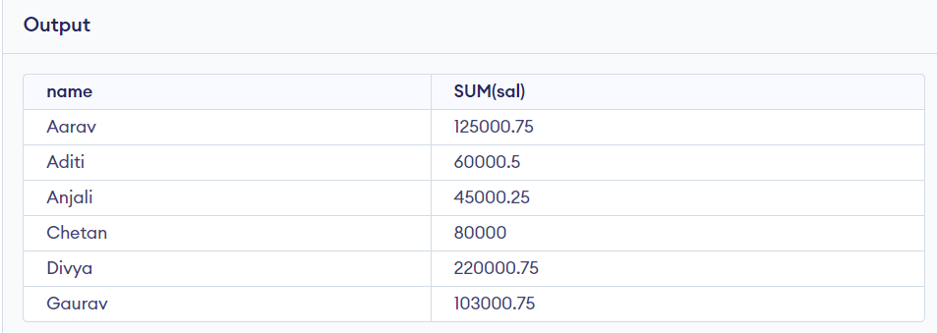
in the above output, the rows with duplicate NAMEs are grouped under the same NAME and their corresponding SALARY is the sum of the SALARY of duplicate rows.

Group By Multiple Columns
SELECT SUBJECT, YEAR, Count(*)
FROM Student
GROUP BY SUBJECT, YEAR;

HAVING Clause in GROUP BY Clause
We know that the WHERE clause is used to place conditions on columns but what if we want to place conditions on groups? This is where the HAVING clause comes into use. We can use the HAVING clause to place conditions to decide which group will be part of the final result set. Also, we cannot use aggregate functions like SUM(), COUNT(), etc. with the WHERE clause. So, we have to use the HAVING clause if we want to use any of these functions in the conditions.
Syntax:
SELECT column1, function_name(column2)
FROM table_name
WHERE condition
GROUP BY column1, column2
HAVING condition
ORDER BY column1, column2;

Example:
SELECT NAME, SUM(sal) FROM Emp
GROUP BY name
HAVING SUM(sal)>50000;

SELECT Statement with HAVING Clause

some important points:
- Having clause is used to filter data according to the conditions provided.
- Having a clause is generally used in reports of large data.
- Having clause is only used with the SELECT clause.
- The expression in the syntax can only have constants.
- In the query, ORDER BY is to be placed after the HAVING clause, if any.
- HAVING Clause is implemented in column operation.
- Having clause is generally used after GROUP BY.

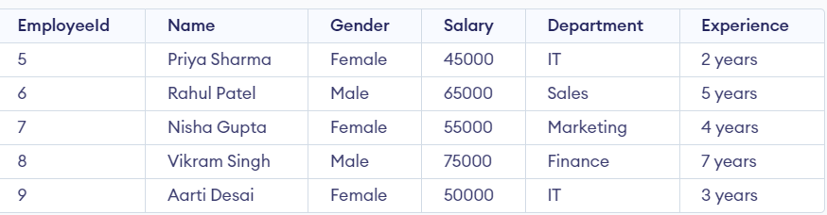
SELECT Department, sum(Salary) as Salary
FROM employee
GROUP BY department;

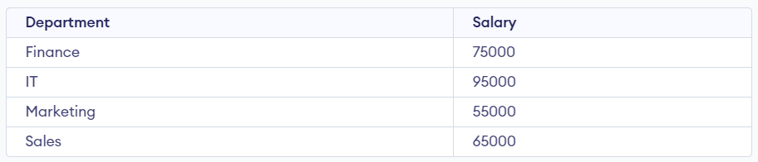

Now if we need to display the departments where the sum of salaries is 50,000 or more. In this condition, we will use the HAVING Clause.

SELECT Department, sum(Salary) as Salary
FROM employee
GROUP BY department
HAVING SUM(Salary) >= 50000;
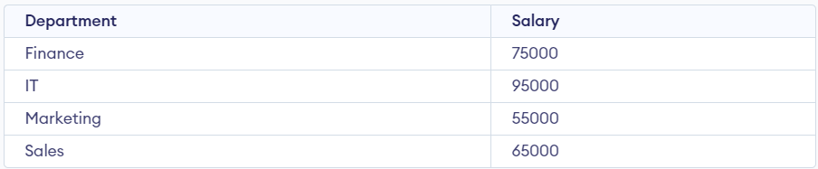

SELECT Statement with ORDER BY clause in SQL
SELECT * FROM Customer ORDER BY Age DESC;

Sort According to Multiple Columns using ORDER BY Clause Example
To sort according to multiple columns, separate the names of columns by the (,) operator.
Syntax:

In this example, we will fetch all data from the table Student and then sort the result in descending order first according to the column age. and then in ascending order according to the column name.
Query:
SELECT * FROM students ORDER BY age DESC, name ASC;

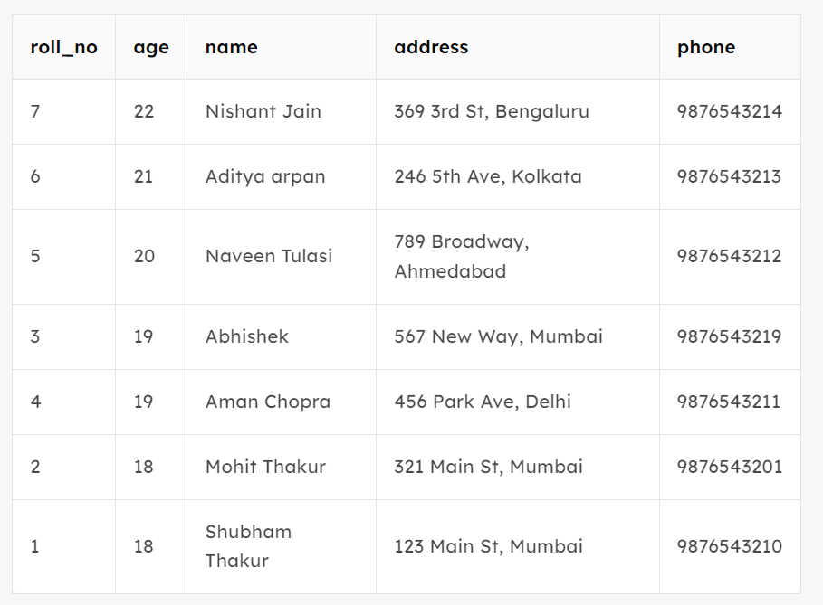
In the above output, we can see that first the result is sorted in descending order according to Age. There are multiple rows of having the same Age. Now, sorting further this result-set according to name will sort the rows with the same Age according to name in ascending order.

SELECT Roll_no, Name, Address
FROM studentinfo
ORDER BY 1

ORDER BY 1 means sorting values according to first column in the SELECT statement

SQL DELETE Statement
SQL DELETE is a basic SQL operation used to delete data in a database. SQL DELETE is an important part of database management DELETE can be used to selectively remove records from a database table based on certain conditions.

Query:
Assume we have created a table named GFG_Employee which contains the personal details of the Employee including their id, name, email and department etc.

Deleting Single Record
You can delete the records named Rithvik by using the below query:

Query
DELETE FROM GFG_Employees WHERE NAME = 'Rithvik';

Deleting Multiple Records

Query
DELETE FROM GFG_Employees
WHERE department = 'Development';

Delete All of the Records
To remove all the entries from the table, you can use the following query:

Query
DELETE FROM GFG_EMPLOyees;
Or
DELETE * FROM GFG_EMPLOyees;

SQL AND Operator
f suppose we want to fetch all the records from the Student table where Age is 18 and ADDRESS is Delhi.
Query
SELECT * FROM Student
WHERE Age = 18 AND ADDRESS = 'Delhi';

SQL OR Operator Example
To fetch all the records from the Student table where NAME is Ram or NAME is SUJIT.
Query
SELECT * FROM Student
WHERE NAME = 'Ram' OR NAME = 'SUJIT';

Combining AND and OR Operators in SQL
Query
SELECT * FROM Student WHERE Age = 18 AND (NAME = 'Ram' OR NAME = 'RAMESH');

DROP and TRUNCATE in SQL
DROP and TRUNCATE in SQL remove data from the table. The main difference between DROP and TRUNCATE commands in SQL is that DROP removes the table or database completely, while TRUNCATE only removes the data, preserving the table structure.

DROP Table
DROP TABLE table_name;
table_name: Name of the table to be deleted.

DROP database
Syntax:
DROP DATABASE database_name;

TRUNCATE TABLE Student_details;
After running the above query Student_details table will be truncated, i.e, the data will be deleted but the structure will remain in the memory for further operations.

SQL NOT Operator
Consider a scenario where you want to select records that do not match a certain condition. For instance, to find employees who do not have a salary greater than 5000, you could use the NOT operator with the greater than (>) operator:
SELECT employee_id, first_name, last_name, salary
FROM employees
WHERE department_id = 5 AND NOT salary > 5000
ORDER BY salary;
Example with IN Operator
The NOT operator can also be used with the IN operator to exclude rows that match any value within a list. For example, to get employees who are not in departments 1, 2, or 3:
SELECT employee_id, first_name, last_name, department_id
FROM employees
WHERE department_id NOT IN (1, 2, 3)
ORDER BY first_name;

SELECT * FROM Customers WHERE NOT Country=’USA’ AND NOT Country=’UK’;

NOT BETWEEN
Select customers with a customerID not between 10 and 60:
SELECT * FROM Customers
WHERE CustomerID NOT BETWEEN 10 AND 60;

NOT IN
Select customers that are not from Paris or London:
SELECT * FROM Customers
WHERE City NOT IN ('Paris', 'London');

NOT Greater Than
Select customers with a CustomerId not greater than 50:
SELECT * FROM Customers
WHERE NOT CustomerID > 50;

NOT Less Than
Select customers with a CustomerID not less than 50:
SELECT * FROM Customers
WHERE NOT CustomerId < 50;
Note: There is a not-less-than operator: !< that would give you the same result.

LIMIT CLAUSE
The LIMIT clause allows you to specify the maximum number of records returned by a query. It is commonly used for limiting query results when only a subset of the data is required, such as, filtering top values, or analyzing a smaller portion of a large table.
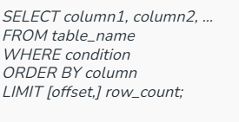
Here,
- offset: number of rows to skip before returning the result set.
- row_count: number of rows to return in the result set.
- SELECT * FROM student
- LIMIT 3;
we will only retrieve 3 rows from the student table using LIMIT

find the top 3 students in a class
SELECT * FROM Student
ORDER BY Grade DESC
LIMIT 3;

In this example, we will skip first 2 values using offset and print only 3 rows.
SELECT *
FROM Student
ORDER BY age
LIMIT 3 OFFSET 2;
Or it canalso be written as
SELECT *
FROM Student
ORDER BY age
LIMIT 2,3;
The first value 2 is the offset value and the second value 3 is the LIMIT value.

In this example, we will retrieve third highest age of student table
SELECT age FROM Student
ORDER BY age LIMIT 2, 1;

